**Flex (Fast Lexical Analyzer Generator )**

FLEX (fast lexical analyzer generator) is a tool/computer program for generating lexical analyzers (scanners or lexers) written by Vern Paxson in C around 1987. It is used together with Berkeley Yacc parser generator or GNU Bison parser generator. Flex and Bison both are more flexible than Lex and Yacc and produces faster code.

Bison produces parser from the input file provided by the user. The function yylex() is automatically generated by the flex when it is provided with a .l file and this yylex() function is expected by parser to call to retrieve tokens from current/this token stream.

Note: The function yylex() is the main flex function which runs the Rule Section and extension (.l) is the extension used to save the programs.

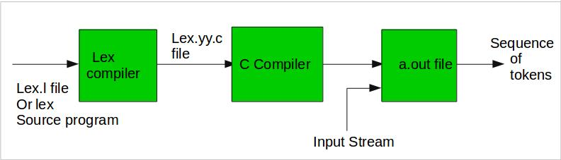

**Step 1:** An input file describes the lexical analyzer to be generated named lex.l is written in lex language. The lex compiler transforms lex.l to C program, in a file that is always named lex.yy.c.  
**Step 2:** The C complier compile lex.yy.c file into an executable file called a.out.  
**Step 3:** The output file a.out take a stream of input characters and produce a stream of tokens.

**Program Structure:**  
In the input file, there are 3 sections:  
**1. Definition Section:** The definition section contains the declaration of variables, regular definitions, manifest constants. In the definition section, text is enclosed in **“%{ %}”** brackets. Anything written in this brackets is copied directly to the file **lex.yy.c**

**Syntax:**

%{

// Definitions

%}

**2. Rules Section:** The rules section contains a series of rules in the form: *pattern action* and pattern must be unintended and action begin on the same line in {} brackets. The rule section is enclosed in **“%% %%”**.  
**Syntax:**

%%

pattern action

%%

**Examples: Table below shows some of the pattern matches.**

| **PATTERN** | **IT CAN MATCH WITH** |
| --- | --- |
| [0-9] | all the digits between 0 and 9 |
| [0+9] | either 0, + or 9 |
| [0, 9] | either 0, ‘, ‘ or 9 |
| [0 9] | either 0, ‘ ‘ or 9 |
| [-09] | either -, 0 or 9 |
| [-0-9] | either – or all digit between 0 and 9 |
| [0-9]+ | one or more digit between 0 and 9 |
| [^a] | all the other characters except a |
| [^A-Z] | all the other characters except the upper case letters |
| a{2, 4} | either aa, aaa or aaaa |
| a{2, } | two or more occurrences of a |
| a{4} | exactly 4 a’s i.e, aaaa |
| . | any character except newline |
| a* | 0 or more occurrences of a |
| a+ | 1 or more occurrences of a |
| [a-z] | all lower case letters |
| [a-zA-Z] | any alphabetic letter |
| w(x | y)z | wxz or wyz |

**3. User Code Section:** This section contain C statements and additional functions. We can also compile these functions separately and load with the lexical analyzer.

Basic Program Structure:

%{

// Definitions

%}

%%

Rules

%%

User code section

**How to run the program:**  
To run the program, it should be first saved with the extension **.l or .lex**. Run the below commands on terminal in order to run the program file.  
**Step 1:** lex filename.l or lex filename.lex depending on the extension file is saved with  
**Step 2:** gcc lex.yy.c  
**Step 3:** ./a.out  
**Step 4:** Provide the input to program in case it is required

**Note:** Press **Ctrl+D** or use some **rule** to stop taking inputs from the user. Please see the output images of below programs to clear if in doubt to run the programs.

**Example 1: Count the number of characters in a string**

|  |
| --- |
| /*** Definition Section has one variable  which can be accessed inside yylex()  and main() ***/  %{  int count = 0;  %}    /*** Rule Section has three rules, first rule  matches with capital letters, second rule  matches with any character except newline and  third rule does not take input after the enter***/  %%  [A-Z] {printf("%s capital letter\n", yytext);         count++;}  .     {printf("%s not a capital letter\n", yytext);}  \n    {return 0;}  %%    /*** Code Section prints the number of  capital letter present in the given input***/  int yywrap(){}  int main(){    // Explanation:  // yywrap() - wraps the above rule section  /* yyin - takes the file pointer            which contains the input*/  /* yylex() - this is the main flex function            which runs the Rule Section*/  // yytext is the text in the buffer    // Uncomment the lines below  // to take input from file  // FILE *fp;  // char filename[50];  // printf("Enter the filename: \n");  // scanf("%s",filename);  // fp = fopen(filename,"r");  // yyin = fp;    yylex();  printf("\nNumber of Captial letters "        "in the given input - %d\n", count);    return 0;  } |

**Output:**  
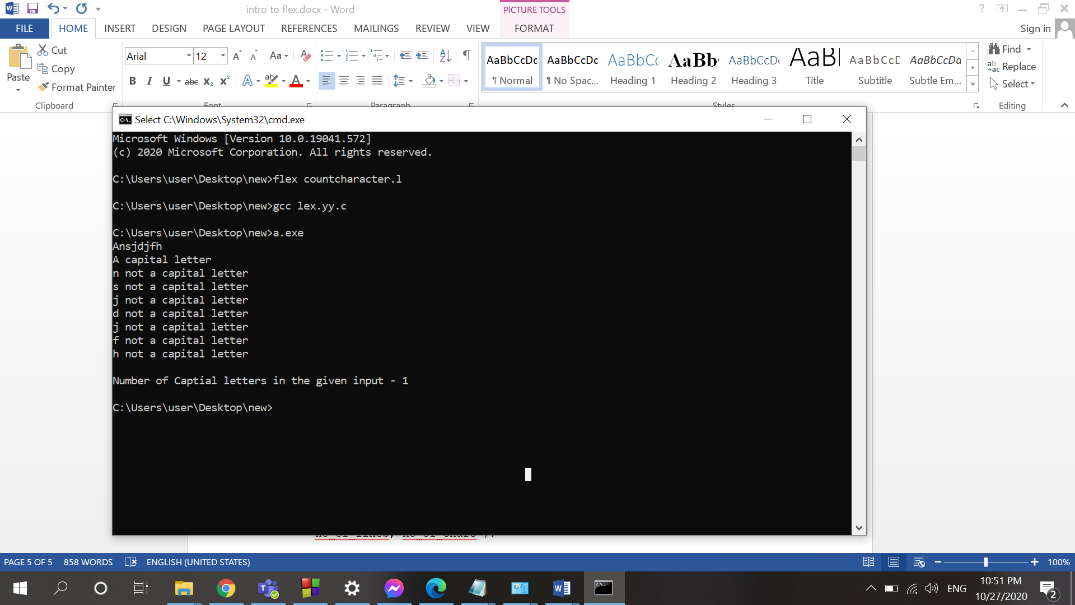

Modification of the first example:

/*** Definition Section has one variable

which can be accessed inside yylex()

and main() ***/

%{

int count = 0;

%}

/*** Rule Section has three rules, first rule

matches with capital letters, second rule

matches with any character except newline and

third rule does not take input after the enter***/

%%

[A-Z] {printf("%s capital letter\n", yytext);

count++;}

. {printf("%s not a capital letter\n", yytext);}

\n {return 0;}

%%

/*** Code Section prints the number of

capital letter present in the given input***/

int yywrap(){}

int main(){

// Explanation:

// yywrap() - wraps the above rule section

/* yyin - takes the file pointer

which contains the input*/

/* yylex() - this is the main flex function

which runs the Rule Section*/

// yytext is the text in the buffer

// Uncomment the lines below

// to take input from file

FILE *fp;

char filename[50];

printf("Enter the filename: \n");

scanf("%s",filename);

fp = fopen(filename,"r");

yyin = fp;

yylex();

printf("\nNumber of Captial letters "

"in the given input - %d\n", count);

return 0;

}

Output:

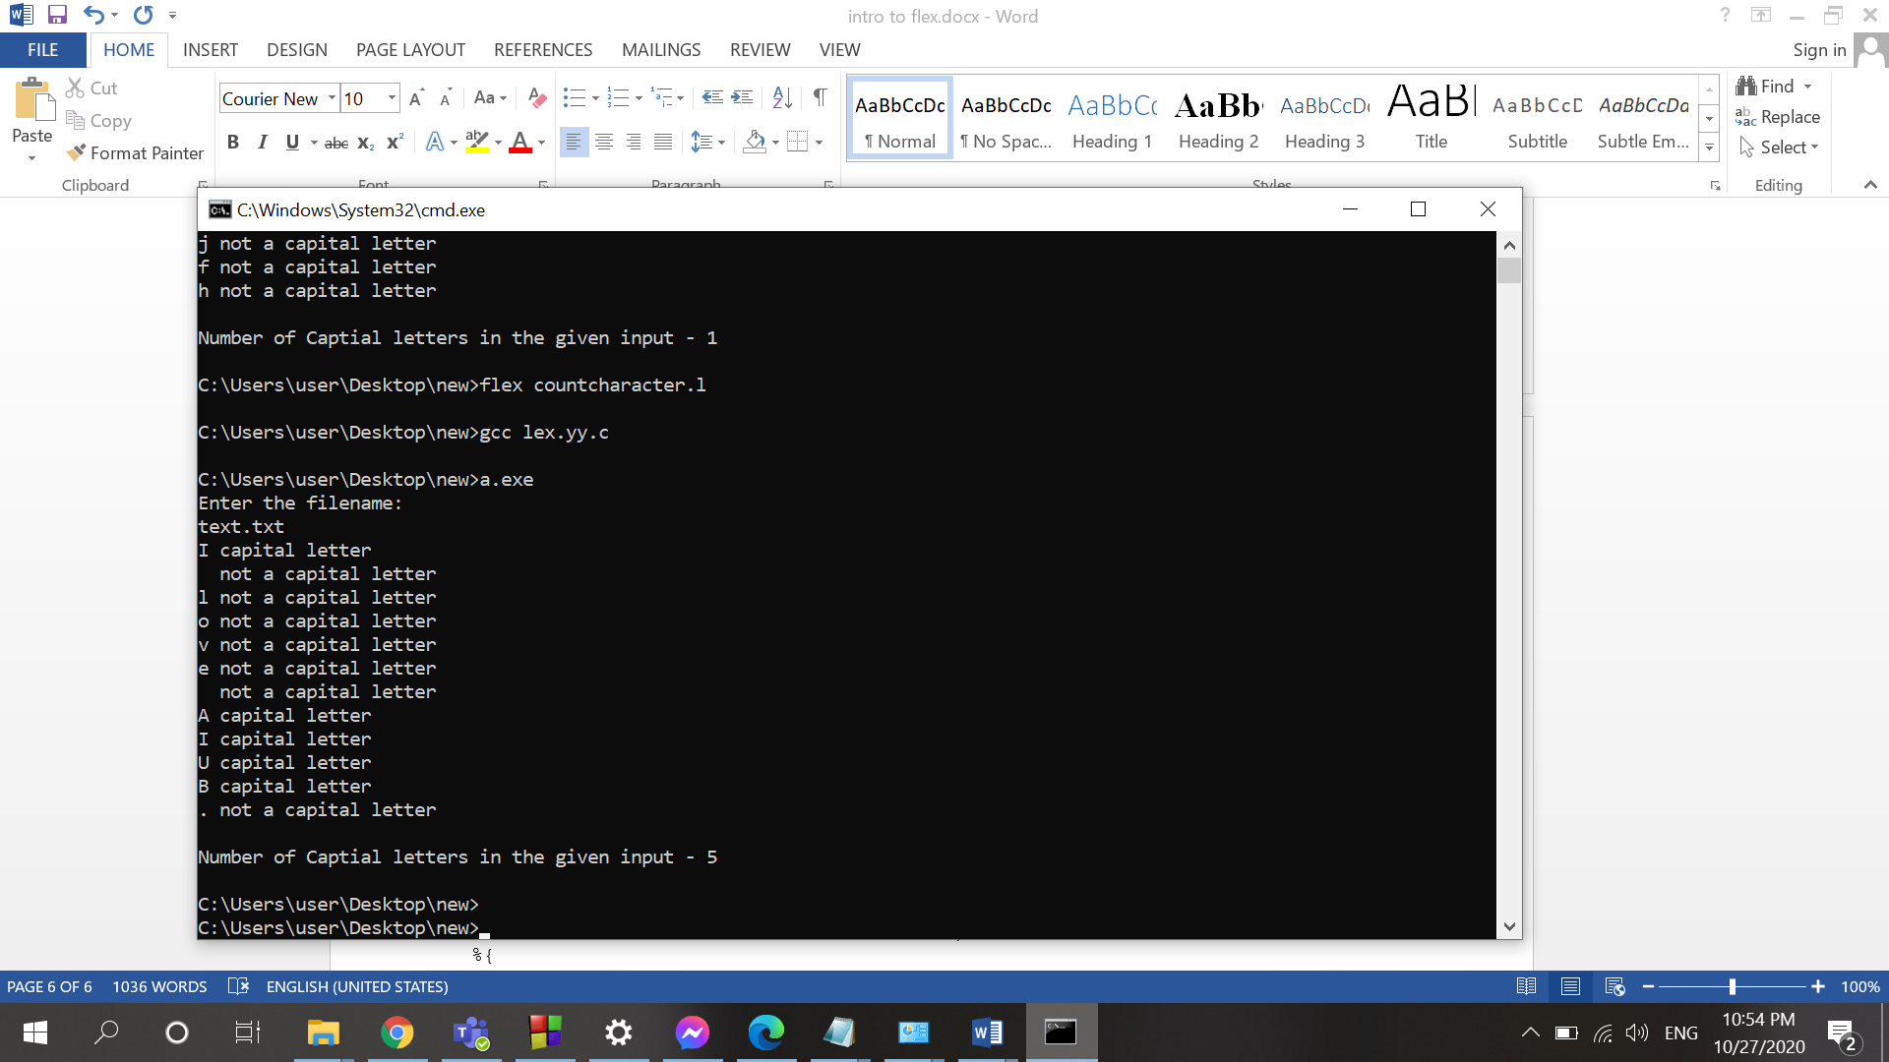

**Example 2: Count the number of characters and number of lines in the input**

|  |
| --- |
| /* Decalring two counters one for number  of lines other for number of characters */  %{  int no_of_lines = 0;  int no_of_chars = 0;  %}    /***rule 1 counts the number of lines,  rule 2 counts the number of characters  and rule 3 specifies when to stop  taking input***/  %%  \n      ++no_of_lines;  .       ++no_of_chars;  end     return 0;  %%    /*** User code section***/  int yywrap(){}  int main(int argc, char **argv)  {    yylex();  printf("number of lines = %d, number of chars = %d\n",         no_of_lines, no_of_chars );    return 0;  } |

Output:

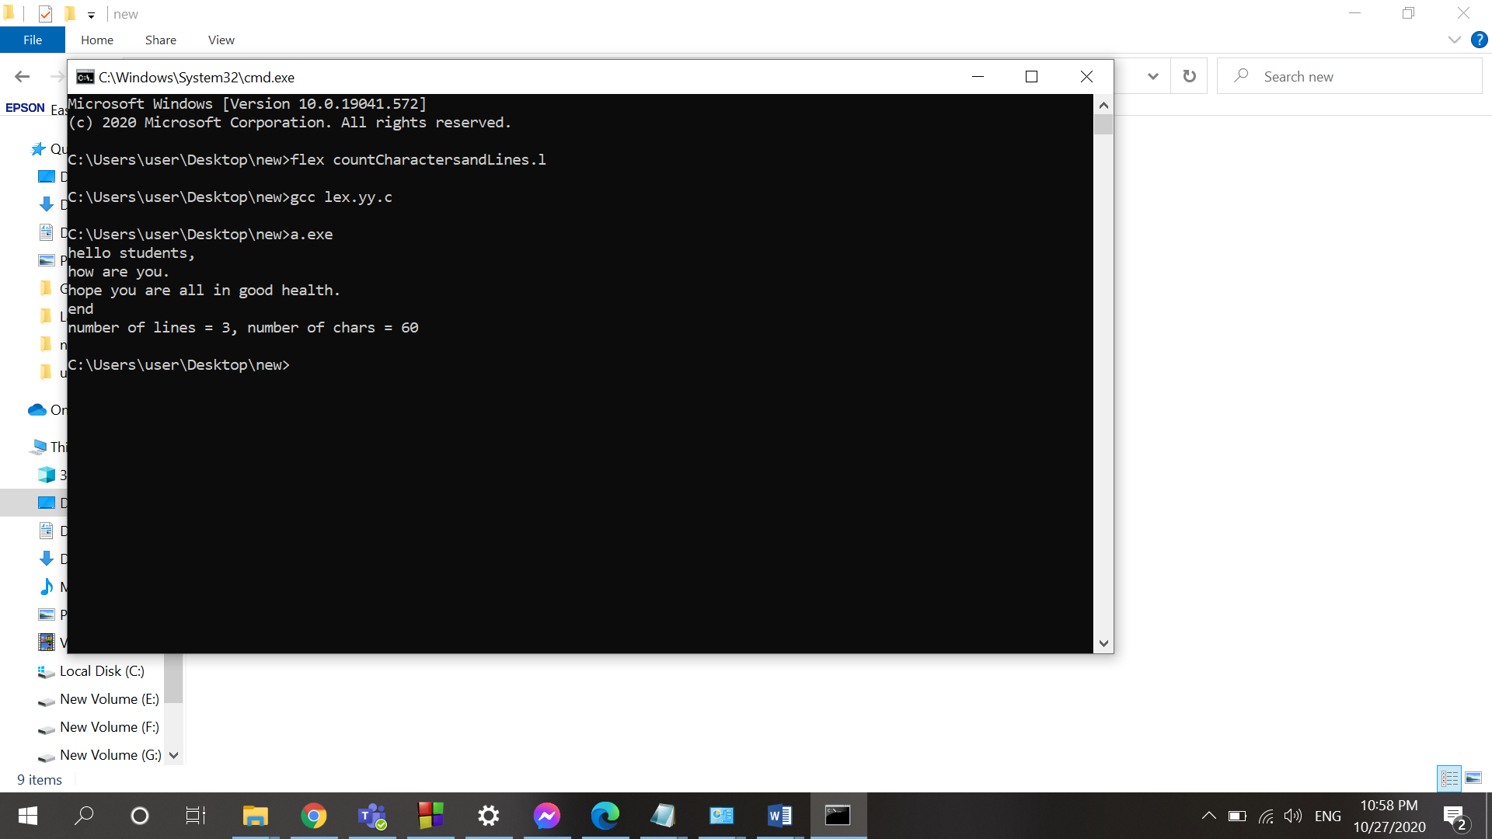

**Example 3: To identify the positive integers**

%%

[+]?[0-9]+ {printf("positive integer\n");}

[-]?[0-9]+ {printf("negative integer\n");}

.

%%

int yywrap()

{

return 1;

}

int main()

{

printf("positive and negative integer recognition\n");

yylex();

return 0;

}

Output:

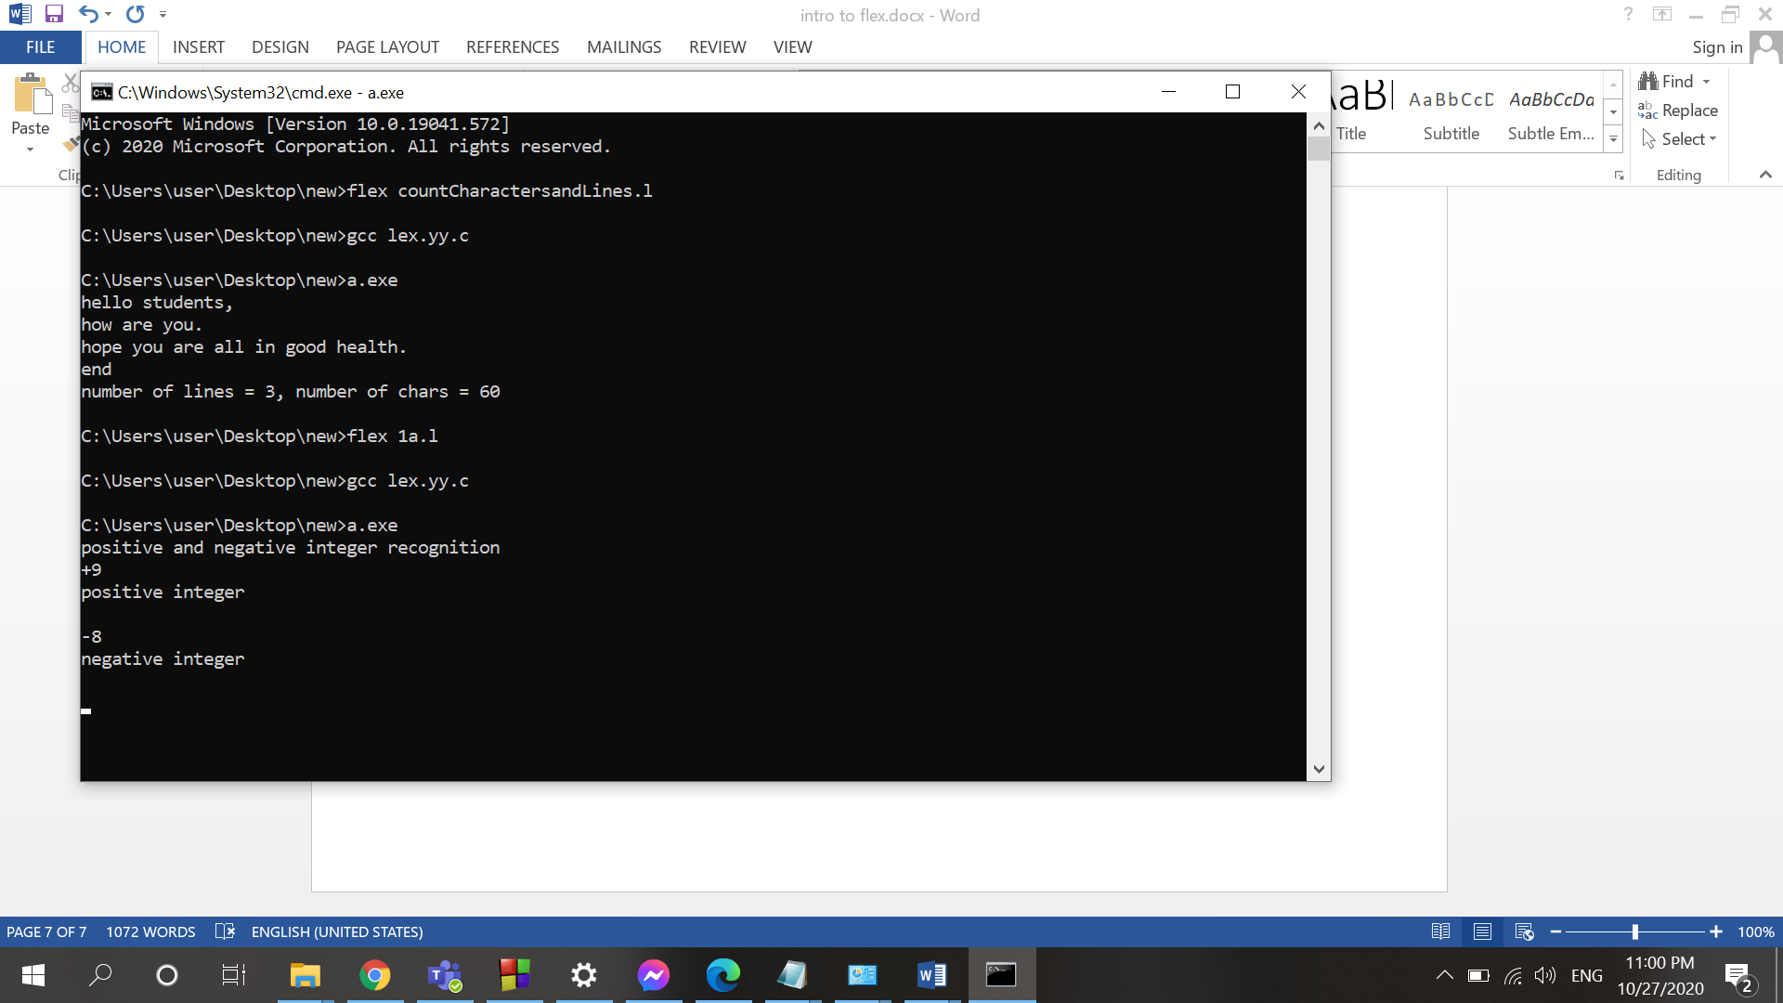

**Example 4: To identify the tokens**

%{

int n = 0 ;

%}

%%

"while"|"if"|"else" {n++;printf("\t keywords : %s", yytext);}

"int"|"float" {n++;printf("\t keywords : %s", yytext);}

"<="|"=="|"="|"++"|"-"|"*"|"+" {n++;printf("\t operator : %s", yytext);}

[a-zA-Z_][a-zA-Z0-9_]* {n++;printf("\t identifier : %s", yytext);}

[(){}|, ;] {n++;printf("\t separator : %s", yytext);}

[0-9]*"."[0-9]+ {n++;printf("\t float : %s", yytext);}

[0-9]+ {n++;printf("\t integer : %s", yytext);}

. ;

%%

int yywrap()

{

return 1;

}

int main()

{

yylex();

printf("\n total no. of token = %d\n", n);

return 0;

}

**Output:**

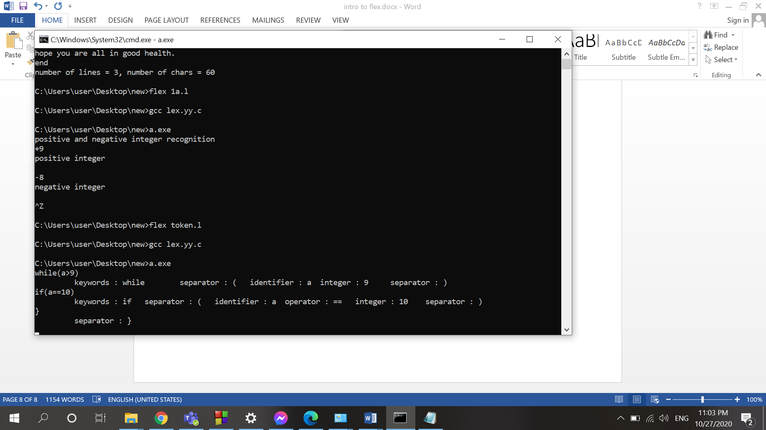

**Acknowledgement:**

1. **https://www.geeksforgeeks.org/introduction-of-lexical-analysis/**